# Breadboard

A breadboard is a plastic board with a grid of holes used for temporary circuit prototyping without soldering.

**Working Principle:**  
The holes are connected in rows and columns with internal metal clips. Horizontal rows are connected. Vertical power rails are used for VCC and GND. Components and jumper wires are inserted to build circuits.

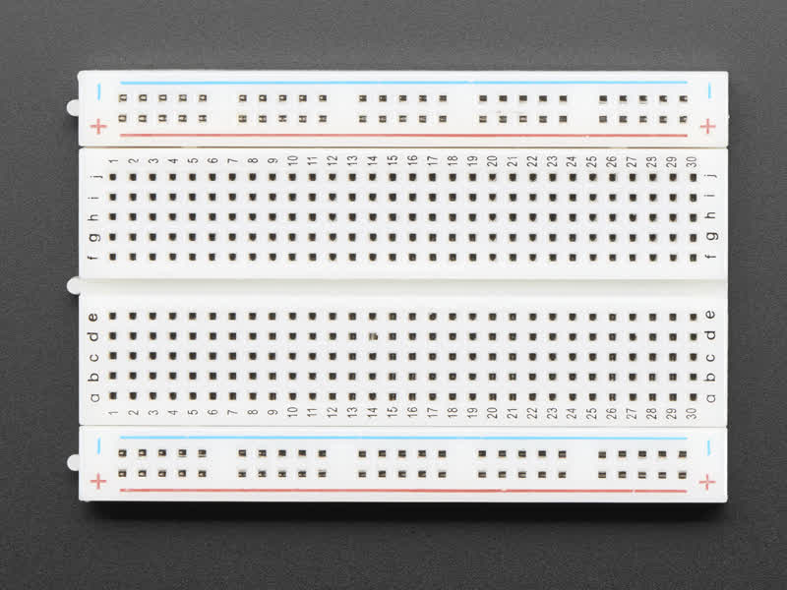**Types**:  
- Full-size  
- Half-size  
- Mini  
- Power rails detachable/attachable

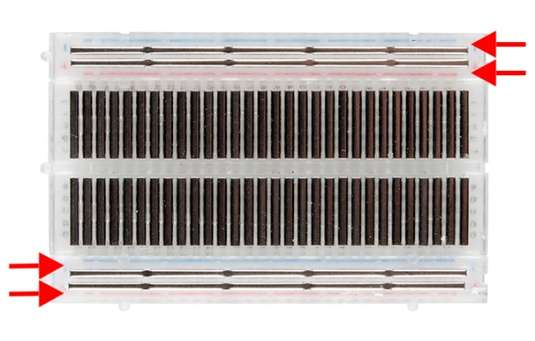**Applications**:  
- Beginner learning tool  
- Testing circuits before soldering  
- Arduino and Raspberry Pi prototyping Fig: Front Side  
- Sensor and actuator interfacing

**Advantages**:  
- No soldering required  
- Reusable  
- Great for quick circuit building  
- Easy to modify and debug

**Disadvantages**:  
- Poor contact reliability   
- Not suitable for high-frequency or power circuits Fig: Back Side  
- Wires can easily fall out